Cities Weather Report using Django

1. We Login on https://openweathermap.org/ and copy the "My API Key".

2. Create Virtual env and a Django Project "weathersite".

3. Create a function "Weather" where we define a list with random 30 cities name.

4. In Weather function we call the "API" with City name and "API key".

5. Fetch Some of value from the JSON which are return by API like: main, cityname, temprature, min temp, max temp, humidity, wind speed.

6. And Weather fuction return the 10 cities record according to page number.

7. We attach MySql database with our project in Setting.

8. We create a superuser where Username = "admin" Password = "pass"

9. After login we can see the result.

Important Link Note:

Username = "admin"

Password = "pass”

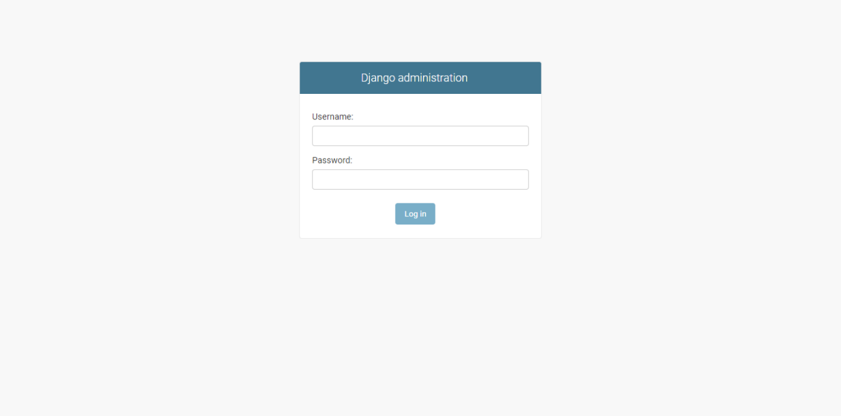This is Django administration Login Page.

Link for login Admin page :- http://127.0.0.1:777/admin/login/?next=/admin/

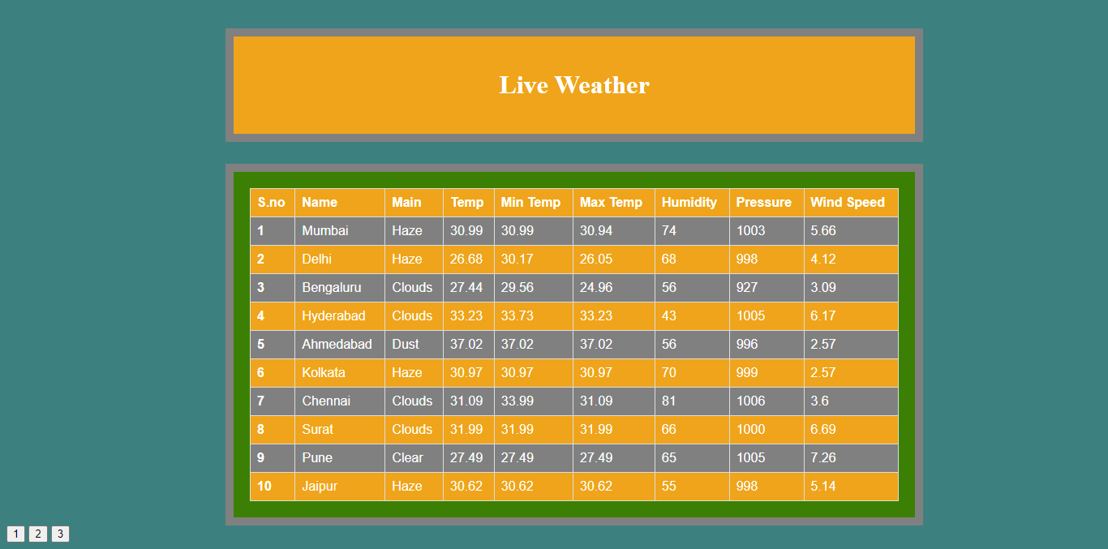Live Weather Data Dashboard

Note:- after the admin Login we open new tab with this link

http://127.0.0.1:777/weather/